|  |
| --- |
| HM73 |
| The Slot Machine |
| **Documentation** |
| Version 1  All work Copyright © 2012 by XX Games.  All rights reserved. |
| **By: Syeda Mehreen** |
|  |



|  |
| --- |
| June 22th 2015 |

Table of Contents

Version History 3

Game Overview 4

Game Play Mechanics 4

Controls 4

Saving and Loading 4

Interface Sketch 4

Menu and Screen Descriptions 5

Game World 6

Game Progression 6

Items 6

Scoring 6

Bonuses 6

Art/Multimedia index 6

Cheat Codes 7

Design Notes 7

Future Features 7

References 8

# Version History

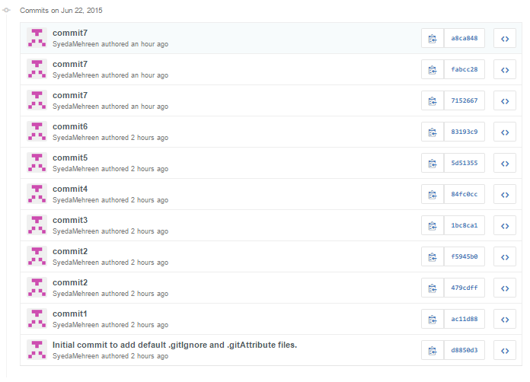

# Game Overview

*This is a game is the virtualization of the real world slot machine. People are crazy about these kinds of games in the casinos. The slots machine generates a significant portion of the money for the casino owners as these machine are designed with the minimum probability of the player to win. In real word real money or casino credits are being used by the player, where as in this game the player are given 1000 dollars of virtual money and which they can use to bet and play the slots.*

# Game Play Mechanics

*The game is moved forwarded by the player by the provided buttons on the screen, each clicking which the specific procedure is started which will result in the win or lose of the player.*

# Controls

*The only control that could be used in this game is the onscreen buttons that are provided to the player.*

# Saving and Loading

*No such feature as saving and loading has been added so far, but could be implemented in the upcoming versions.*

# Interface Sketch

*The game interface is kept simple in order the player is not distracted from the game. The game has only one screen which gets updated as the player continues with the game.*

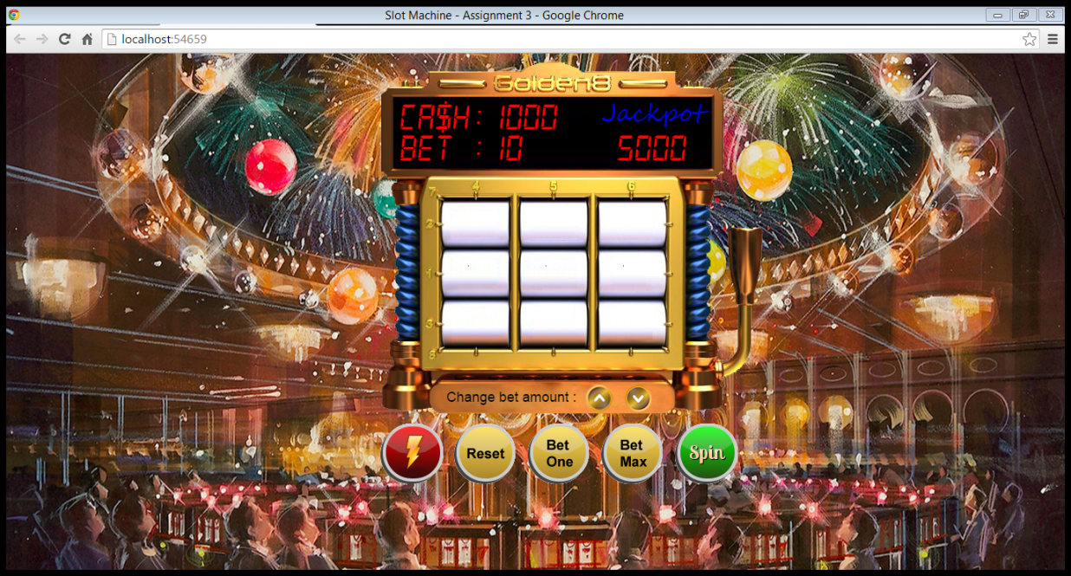

# Menu and Screen Descriptions

*The game does not have any menu as it is expected that the player is already familiar with e concepts of the slots.*

*The game resides on the right side of the screen of the window and at the top the Cash the player has, the bet amount and the jackpot amount is displayed. At the bottom button or controls are being provided to the user, which help him in continuing the game further*

**

# Game World

*The game has its own environment that is used to get the player into the simulation that he is playing on a real slot machine.*

# Game Progression

*The game progresses till the player has money make the bet and spin the reels. As soon as the money is finished the player is drawn out of the game though he may wish to restart the game over.*

# Items

*At each successful spin the reels generate the items, on which based the amount won by the player is decided.*

# Scoring

*The score the player is determined by the cash he has earned and it depends on the spins that he had made and earned out of them. Each time player wins something that corresponding points are added to the cash of the player.*

# Bonuses

*One jackpot is also there. In the backend this is simple concept of comparing two randomly generated values which on success will lead to the player winning the jackpot.*

# Art/Multimedia index

* *reels*
* *banana.png*
* *bar.png*
* *bell.png*
* *blank.png*
* *cherry.png*
* *dollars.png*
* *hearts.png*
* *seven.png*
* *arrow_down.png*
* *arrow_up.png*
* *bet_max.png*
* *bet_one.png*
* *casino_bg.png*
* *power.png*
* *reset.png*
* *slot_machine_face.png*
* *spin.png*
* *spin_button.png*

# Cheat Codes

*No cheat codes are applicable for this game so far as the difficulty level is not much. But could be considered in the forthcoming versions.*

# Design Notes

*The designing of the game is kept simple to make it more user friendly. And the images used are from the various external sources.*

# Future Features

*In future the new features could be introduces like 3D characters, animation effects, sound effects, graphical rendering, etc.*

# References

*The images and other visible components used in this game are taken from various sources*

* *Google images*
* *www.fontspace.com*
* *www.buttoncreator.com*
* *www.w3schools.com*